Equality of Geometric Expressions

Definition
# Source: AI Source: Provided by: [Data Path: Persons Table -> ID Column: 1, Name_En Column: Motasem Essam] -> From: [ChatGPT] on [7/25/2026]
Equality of Geometric Expressions is a type of geometric equality in which two mathematical expressions representing geometric quantities or relationships are equal.
It is written using:
$$\boxed{E_{1}=E_{2}}$$
where $E_{1}$and $E_{2}$are geometric expressions.
The expressions may represent:
- lengths
- distances
- angles
- areas
- perimeters
- radii
- diameters
- volumes
- ratios
- coordinates
- other geometric quantities
For example:
$$\boxed{AB+BC=AC}$$
is an equality of geometric expressions based on segment addition.
Another example is:
$$\boxed{2πr=πd}$$
because:
$$d=2r.$$

Simple Definition
# Source: AI Source: Provided by: [Data Path: Persons Table -> ID Column: 1, Name_En Column: Motasem Essam] -> From: [ChatGPT] on [7/25/2026]
Equality of Geometric Expressions means that two mathematical expressions representing geometric quantities have exactly the same value.
For example:
$$2r=d$$
and:
$$πd=2πr$$
represent equal geometric quantities.

Fundamental Concept
# Source: AI Source: Provided by: [Data Path: Persons Table -> ID Column: 1, Name_En Column: Motasem Essam] -> From: [ChatGPT] on [7/25/2026]
A geometric expression combines numbers, variables, geometric measurements, operations, and sometimes known geometric constants.
For example:
$$2\left(l+w\right)$$
is an expression for the perimeter of a rectangle.
If two rectangles have equal perimeters, we can write:
$$\boxed{2\left(l_{1}+w_{1}\right)=2\left(l_{2}+w_{2}\right)}$$
The equality does not necessarily mean that the individual components are equal. It means that the complete expressions have the same value.
The fundamental structure is:
$$\boxed{{\text{Geometric Expression}}_{1}={\text{Geometric Expression}}_{2}}$$

Main Types
# Source: AI Source: Provided by: [Data Path: Persons Table -> ID Column: 1, Name_En Column: Motasem Essam] -> From: [ChatGPT] on [7/25/2026]
A practical classification is:
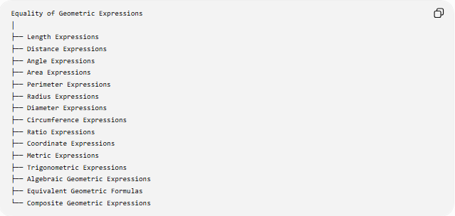
Equality of Geometric Expressions
│
├── Length Expressions
├── Distance Expressions
├── Angle Expressions
├── Area Expressions
├── Perimeter Expressions
├── Radius Expressions
├── Diameter Expressions
├── Circumference Expressions
├── Ratio Expressions
├── Coordinate Expressions
├── Metric Expressions
├── Trigonometric Expressions
├── Algebraic Geometric Expressions
├── Equivalent Geometric Formulas
└── Composite Geometric Expressions
This is a practical classification, rather than a universally standardized taxonomy.

Equality of Length Expressions
# Source: AI Source: Provided by: [Data Path: Persons Table -> ID Column: 1, Name_En Column: Motasem Essam] -> From: [ChatGPT] on [7/25/2026]
Length expressions represent segment lengths or other linear measurements.
Example
Suppose:
$$AB=3x+5$$
and:
$$CD=2x+12.$$
If:
$$AB=CD,$$
then:
$$\boxed{3x+5=2x+12}.$$
Solving:
$$x=7.$$
Therefore:
$$AB=CD=26.$$
Another Example
Segment addition gives:
$$\boxed{AB+BC=AC}.$$
If:
$$AB=5, BC=7,$$
then:
$$5+7=AC$$
and:
$$\boxed{AC=12}.$$

Equality of Distance Expressions
# Source: AI Source: Provided by: [Data Path: Persons Table -> ID Column: 1, Name_En Column: Motasem Essam] -> From: [ChatGPT] on [7/25/2026]
Distance expressions describe distances between points or geometric objects.
The coordinate distance formula is:
$$d\left(P , Q\right)=\sqrt{{\left(x_{2}-x_{1}\right)}^{2}+{\left(y_{2}-y_{1}\right)}^{2}}.$$
Two distances can therefore be expressed as:
$$d\left(P , Q\right)=d\left(R , S\right).$$
Example
Let:
$$P=\left(0 , 0\right), Q=\left(3 , 4\right)$$
and:
$$R=\left(1 , 1\right), S=\left(4 , 5\right).$$
Then:
$$PQ=\sqrt{3^{2}+4^{2}}=5$$
and:
$$RS=\sqrt{3^{2}+4^{2}}=5.$$
Therefore:
$$\boxed{PQ=RS}.$$

Equality of Angle Expressions
# Source: AI Source: Provided by: [Data Path: Persons Table -> ID Column: 1, Name_En Column: Motasem Essam] -> From: [ChatGPT] on [7/25/2026]
Angles can also be represented by expressions.
For example:
$$m∠A=3x+10$$
and:
$$m∠B=5x-20.$$
If:
$$m∠A=m∠B,$$
then:
$$3x+10=5x-20.$$
Therefore:
$$x=15.$$
Substitution gives:
$$m∠A=m∠B={55}^{∘}.$$
Thus:
$$\boxed{3x+10=5x-20}.$$
is an equality of geometric angle expressions.

Equality of Area Expressions
# Source: AI Source: Provided by: [Data Path: Persons Table -> ID Column: 1, Name_En Column: Motasem Essam] -> From: [ChatGPT] on [7/25/2026]
Area formulas often produce geometric expressions.
Rectangle
$$A=lw$$
Triangle
$$A=\frac{1}{2}bh$$
Circle
$$A=πr^{2}$$
Two areas can be expressed as:
$$\boxed{l_{1}w_{1}=\frac{1}{2}b_{2}h_{2}}.$$
Example
A rectangle has:
$$l=6, w=4.$$
Therefore:
$$A=6\left(4\right)=24.$$
A triangle has:
$$b=8, h=6.$$
Then:
$$A=\frac{1}{2}\left(8\right)\left(6\right)=24.$$
Therefore:
$$\boxed{6\left(4\right)=\frac{1}{2}\left(8\right)\left(6\right)}$$
and both figures have equal areas.

Equality of Perimeter Expressions
# Source: AI Source: Provided by: [Data Path: Persons Table -> ID Column: 1, Name_En Column: Motasem Essam] -> From: [ChatGPT] on [7/25/2026]
The perimeter of a rectangle is:
$$P=2\left(l+w\right).$$
Suppose two rectangles have dimensions:
$$l_{1}=8, w_{1}=5$$
and:
$$l_{2}=10, w_{2}=3.$$
Then:
$$P_{1}=2\left(8+5\right)=26$$
and:
$$P_{2}=2\left(10+3\right)=26.$$
Therefore:
$$\boxed{2\left(8+5\right)=2\left(10+3\right)}$$
and:
$$\boxed{P_{1}=P_{2}}.$$
Notice that:
$$8≠10$$
and:
$$5≠3,$$
but the complete perimeter expressions are equal.

Equality of Radius Expressions
# Source: AI Source: Provided by: [Data Path: Persons Table -> ID Column: 1, Name_En Column: Motasem Essam] -> From: [ChatGPT] on [7/25/2026]
The radius of a circle can be represented in several equivalent ways.
From diameter:
$$\boxed{r=\frac{d}{2}}$$
From circumference:
$$\boxed{r=\frac{C}{2π}}$$
From area:
$$\boxed{r=\sqrt{\frac{A}{π}}}.$$
Therefore:
$$\boxed{\frac{d}{2}=\frac{C}{2π}=\sqrt{\frac{A}{π}}}$$
when $d,C,A$refer to the same circle.
Example
If:
$$d=10,$$
then:
$$r=\frac{10}{2}=5.$$
If:
$$C=10π,$$
then:
$$r=\frac{10π}{2π}=5.$$
Thus:
$$\boxed{\frac{d}{2}=\frac{C}{2π}=5}.$$

Equality of Diameter Expressions
# Source: AI Source: Provided by: [Data Path: Persons Table -> ID Column: 1, Name_En Column: Motasem Essam] -> From: [ChatGPT] on [7/25/2026]
Because:
$$d=2r,$$
a diameter can be represented by:
$$\boxed{d=2r}.$$
It can also be obtained from circumference:
$$\boxed{d=\frac{C}{π}}.$$
Or from area:
$$\boxed{d=2\sqrt{\frac{A}{π}}}.$$
Therefore:
$$\boxed{2r=\frac{C}{π}=2\sqrt{\frac{A}{π}}}$$
for the same circle.

Equality of Circumference Expressions
# Source: AI Source: Provided by: [Data Path: Persons Table -> ID Column: 1, Name_En Column: Motasem Essam] -> From: [ChatGPT] on [7/25/2026]
The circumference of a circle can be written as:
$$\boxed{C=2πr}$$
or:
$$\boxed{C=πd}.$$
Because:
$$d=2r,$$
we have:
$$\boxed{2πr=πd}.$$
Example
If:
$$r=5,$$
then:
$$C=2π\left(5\right)=10π.$$
If:
$$d=10,$$
then:
$$C=π\left(10\right)=10π.$$
Therefore:
$$\boxed{2πr=πd}.$$

Equality of Ratio Expressions
# Source: AI Source: Provided by: [Data Path: Persons Table -> ID Column: 1, Name_En Column: Motasem Essam] -> From: [ChatGPT] on [7/25/2026]
Geometric ratios can also be represented by expressions.
For example:
$$\boxed{\frac{AB}{BC}=\frac{DE}{EF}}$$
is an equality of geometric expressions.
Example
If:
$$AB=4, BC=6$$
and:
$$DE=8, EF=12,$$
then:
$$\frac{4}{6}=\frac{8}{12}.$$
Both simplify to:
$$\boxed{\frac{2}{3}}.$$
Therefore:
$$\boxed{\frac{AB}{BC}=\frac{DE}{EF}}.$$

Equality of Scale-Factor Expressions
# Source: AI Source: Provided by: [Data Path: Persons Table -> ID Column: 1, Name_En Column: Motasem Essam] -> From: [ChatGPT] on [7/25/2026]
For similar figures, the scale factor can be represented by several equivalent ratios:
$$\boxed{k=\frac{L_{2}}{L_{1}}}$$
For similar figures:
$$\boxed{\frac{AB}{DE}=\frac{BC}{EF}=\frac{AC}{DF}=k}$$
Thus several geometric expressions have the same value.
Example
If:
$$AB=6, DE=9,$$
then:
$$\frac{AB}{DE}=\frac{6}{9}=\frac{2}{3}.$$
If:
$$BC=8, EF=12,$$
then:
$$\frac{BC}{EF}=\frac{8}{12}=\frac{2}{3}.$$
Therefore:
$$\boxed{\frac{AB}{DE}=\frac{BC}{EF}=\frac{2}{3}}.$$

Equality of Coordinate Expressions
# Source: AI Source: Provided by: [Data Path: Persons Table -> ID Column: 1, Name_En Column: Motasem Essam] -> From: [ChatGPT] on [7/25/2026]
Coordinate geometry frequently produces geometric expressions that can be shown equal.
Distance
$$AB=\sqrt{{\left(x_{B}-x_{A}\right)}^{2}+{\left(y_{B}-y_{A}\right)}^{2}}.$$
Midpoint
$$M_{x}=\frac{x_{1}+x_{2}}{2} \\ M_{y}=\frac{y_{1}+y_{2}}{2}.$$
Slope
$$m=\frac{y_{2}-y_{1}}{x_{2}-x_{1}}.$$
Two geometric quantities may be represented by equivalent coordinate expressions.
Example
For:
$$A=\left(0 , 0\right), B=\left(4 , 3\right),$$
the distance is:
$$AB=\sqrt{4^{2}+3^{2}}=5.$$
If another segment has:
$$CD=\sqrt{25},$$
then:
$$\boxed{AB=CD}.$$

Equality of Equivalent Geometric Formulas
# Source: AI Source: Provided by: [Data Path: Persons Table -> ID Column: 1, Name_En Column: Motasem Essam] -> From: [ChatGPT] on [7/25/2026]
Sometimes two expressions look different but represent exactly the same geometric quantity.
This is an important form of equality.
Circle circumference
$$\boxed{2πr=πd}$$
because:
$$d=2r.$$
Rectangle perimeter
$$P=2l+2w$$
and:
$$P=2\left(l+w\right).$$
Therefore:
$$\boxed{2l+2w=2\left(l+w\right)}.$$
Triangle area
The same area can sometimes be represented using different equivalent expressions.
For example:
$$A=\frac{1}{2}bh$$
and if $b=2a$:
$$A=ah.$$
Thus:
$$\boxed{\frac{1}{2}\left(2a\right)h=ah}.$$

Equality of Algebraically Equivalent Geometric Expressions
# Source: AI Source: Provided by: [Data Path: Persons Table -> ID Column: 1, Name_En Column: Motasem Essam] -> From: [ChatGPT] on [7/25/2026]
Two geometric expressions can be equal because of algebraic identities.
Example 1
Rectangle perimeter:
$$2\left(l+w\right)$$
and:
$$2l+2w.$$
By the distributive property:
$$\boxed{2\left(l+w\right)=2l+2w}.$$
Example 2
Difference of squares:
$$a^{2}-b^{2}$$
equals:
$$\left(a-b\right)\left(a+b\right).$$
Therefore:
$$\boxed{a^{2}-b^{2}=\left(a-b\right)\left(a+b\right)}.$$
If $a$and $b$represent geometric lengths, both expressions represent the same geometric quantity.

Equality of Trigonometric Geometric Expressions
# Source: AI Source: Provided by: [Data Path: Persons Table -> ID Column: 1, Name_En Column: Motasem Essam] -> From: [ChatGPT] on [7/25/2026]
Geometric quantities involving angles can also be expressed using trigonometric functions.
For a right triangle:
$$\sin{θ}=\frac{\text{opposite}}{\text{hypotenuse}} \\ \cos{θ}=\frac{\text{adjacent}}{\text{hypotenuse}} \\ \tan{θ}=\frac{\text{opposite}}{\text{adjacent}}.$$
Example
If:
$$\sin{θ}=\frac{3}{5},$$
then:
$$\boxed{\sin{θ}=\frac{\text{opposite}}{\text{hypotenuse}}=\frac{3}{5}}.$$
Different geometric expressions can therefore represent the same trigonometric value.

Equality of Metric Expressions
# Source: AI Source: Provided by: [Data Path: Persons Table -> ID Column: 1, Name_En Column: Motasem Essam] -> From: [ChatGPT] on [7/25/2026]
Metric expressions describe measurable geometric quantities.
Examples include:
$$AB^{2} \\ BC^{2} \\ AC^{2}$$
and:
$$d{\left(P , l\right)}^{2}.$$
Pythagorean Example
For a right triangle:
$$\boxed{a^{2}+b^{2}=c^{2}}.$$
Here, the expression:
$$a^{2}+b^{2}$$
and the expression:
$$c^{2}$$
are equal.
For:
$$a=3, b=4, c=5, \\ 3^{2}+4^{2}=5^{2} \\ 9+16=25.$$
Therefore:
$$\boxed{a^{2}+b^{2}=c^{2}}.$$

Equality of Composite Geometric Expressions
# Source: AI Source: Provided by: [Data Path: Persons Table -> ID Column: 1, Name_En Column: Motasem Essam] -> From: [ChatGPT] on [7/25/2026]
A complex geometric quantity can be represented as a combination of simpler expressions.
Example: Composite Area
Suppose a shape consists of a rectangle and a triangle.
Its total area might be:
$$A=lw+\frac{1}{2}bh.$$
If another decomposition gives:
$$A=48+12,$$
then:
$$\boxed{lw+\frac{1}{2}bh=60}.$$
If a second method gives:
$$A=60,$$
then:
$$\boxed{lw+\frac{1}{2}bh=60}.$$
Different expressions describe the same geometric area.

Equality from Segment Addition
# Source: AI Source: Provided by: [Data Path: Persons Table -> ID Column: 1, Name_En Column: Motasem Essam] -> From: [ChatGPT] on [7/25/2026]
Segment addition is one of the most important sources of geometric expressions.
If $B$lies between $A$and $C$:
$$\boxed{AB+BC=AC}.$$
Example
If:
$$AB=7, BC=5,$$
then:
$$7+5=AC$$
so:
$$\boxed{AC=12}.$$
The expression:
$$AB+BC$$
and the expression:
$$AC$$
represent the same length.

Equality from Angle Addition
# Source: AI Source: Provided by: [Data Path: Persons Table -> ID Column: 1, Name_En Column: Motasem Essam] -> From: [ChatGPT] on [7/25/2026]
If ray $BD$lies inside $∠ABC$:
$$\boxed{m∠ABD+m∠DBC=m∠ABC}$$
Example
If:
$$m∠ABD={35}^{∘}$$
and:
$$m∠DBC={25}^{∘},$$
then:
$${35}^{∘}+{25}^{∘}={60}^{∘}.$$
Therefore:
$$\boxed{m∠ABC={60}^{∘}}.$$

Equality of Expressions from Geometric Theorems
# Source: AI Source: Provided by: [Data Path: Persons Table -> ID Column: 1, Name_En Column: Motasem Essam] -> From: [ChatGPT] on [7/25/2026]
Geometric theorems frequently establish equality between expressions.
Pythagorean Theorem
$$\boxed{a^{2}+b^{2}=c^{2}}$$
Stewart's Theorem
$$\boxed{b^{2}m+c^{2}n=a\left(d^{2}+mn\right)}$$
Apollonius' Theorem
$$\boxed{AB^{2}+AC^{2}=2\left(AD^{2}+BD^{2}\right)}$$
Law of Cosines
$$\boxed{c^{2}=a^{2}+b^{2}-2ab\cos{C}}$$
Each theorem creates an equality between geometric expressions.

Equality of Geometric Expressions vs Geometric Equality
# Source: AI Source: Provided by: [Data Path: Persons Table -> ID Column: 1, Name_En Column: Motasem Essam] -> From: [ChatGPT] on [7/25/2026]
These concepts are closely related but not identical.
Geometric Equality
Focuses on the equality of geometric quantities:
$$\boxed{AB=CD}$$
Equality of Geometric Expressions
Focuses on the equality of the mathematical expressions used to represent those quantities:
$$\boxed{3x+5=2x+12}.$$
The second can be used to establish the first.
For example:
$$AB=3x+5 \\ CD=2x+12$$
and:
$$AB=CD.$$
Therefore:
$$\boxed{3x+5=2x+12}.$$

Expression Equality Does Not Require Identical Form
# Source: AI Source: Provided by: [Data Path: Persons Table -> ID Column: 1, Name_En Column: Motasem Essam] -> From: [ChatGPT] on [7/25/2026]
Two expressions can be equal even when they look different.
For example:
$$\boxed{2\left(l+w\right)=2l+2w}$$
or:
$$\boxed{2πr=πd}.$$
The expressions have different forms but the same value under the appropriate geometric relationships.
This is called equivalent expression equality.

Equality of Expressions vs Equality of Individual Components
# Source: AI Source: Provided by: [Data Path: Persons Table -> ID Column: 1, Name_En Column: Motasem Essam] -> From: [ChatGPT] on [7/25/2026]
This distinction is very important.
Suppose:
$$l_{1}+w_{1}=l_{2}+w_{2}.$$
This does not mean:
$$l_{1}=l_{2}$$
and:
$$w_{1}=w_{2}.$$
Example
$$8+5=10+3$$
because:
$$13=13.$$
But:
$$8≠10$$
and:
$$5≠3.$$
Thus:
$$\boxed{8+5=10+3}$$
is an equality of expressions, not equality of the individual terms.

Important Properties Used with Geometric Expressions
# Source: AI Source: Provided by: [Data Path: Persons Table -> ID Column: 1, Name_En Column: Motasem Essam] -> From: [ChatGPT] on [7/25/2026]
Geometric expression equality relies heavily on algebraic equality properties.
Reflexive Property
$$\boxed{E=E}$$
Example:
$$AB=AB.$$
Symmetric Property
If:
$$E_{1}=E_{2},$$
then:
$$\boxed{E_{2}=E_{1}}.$$
Transitive Property
If:
$$E_{1}=E_{2}$$
and:
$$E_{2}=E_{3},$$
then:
$$\boxed{E_{1}=E_{3}}.$$
Substitution Property
If:
$$AB=5$$
then an expression containing $AB$can be replaced by $5$.
For example:
$$AB+BC=5+BC.$$
Addition Property
If:
$$a=b,$$
then:
$$\boxed{a+c=b+c}.$$
Multiplication Property
If:
$$a=b,$$
then:
$$\boxed{ka=kb}.$$
These properties allow geometric expressions to be manipulated while preserving equality.

Example: Complete Geometric Expression Proof
# Source: AI Source: Provided by: [Data Path: Persons Table -> ID Column: 1, Name_En Column: Motasem Essam] -> From: [ChatGPT] on [7/25/2026]
Suppose $M$is the midpoint of $AB$, and:
$$AB=2x+6.$$
Find $AM$.
Because $M$is the midpoint:
$$AM=MB.$$
By segment addition:
$$AM+MB=AB.$$
Therefore:
$$AM+AM=2x+6. \\ 2AM=2x+6. \\ \boxed{AM=x+3}.$$
Here, several geometric expressions are connected:
$$\boxed{AM+MB=AB} \\ \boxed{AM=MB} \\ \boxed{2AM=2x+6} \\ \boxed{AM=x+3}$$

Classification Summary
# Source: AI Source: Provided by: [Data Path: Persons Table -> ID Column: 1, Name_En Column: Motasem Essam] -> From: [ChatGPT] on [7/25/2026]
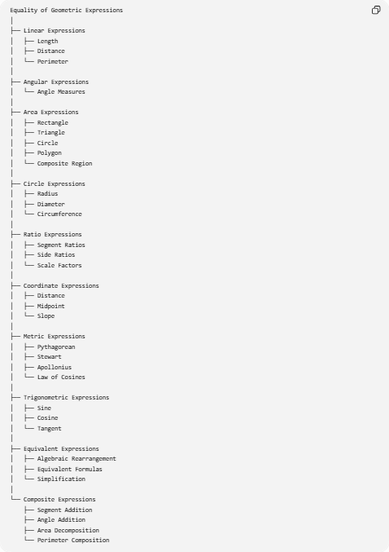
Equality of Geometric Expressions
│
├── Linear Expressions
│ ├── Length
│ ├── Distance
│ └── Perimeter
│
├── Angular Expressions
│ └── Angle Measures
│
├── Area Expressions
│ ├── Rectangle
│ ├── Triangle
│ ├── Circle
│ ├── Polygon
│ └── Composite Region
│
├── Circle Expressions
│ ├── Radius
│ ├── Diameter
│ └── Circumference
│
├── Ratio Expressions
│ ├── Segment Ratios
│ ├── Side Ratios
│ └── Scale Factors
│
├── Coordinate Expressions
│ ├── Distance
│ ├── Midpoint
│ └── Slope
│
├── Metric Expressions
│ ├── Pythagorean
│ ├── Stewart
│ ├── Apollonius
│ └── Law of Cosines
│
├── Trigonometric Expressions
│ ├── Sine
│ ├── Cosine
│ └── Tangent
│
├── Equivalent Expressions
│ ├── Algebraic Rearrangement
│ ├── Equivalent Formulas
│ └── Simplification
│
└── Composite Expressions
├── Segment Addition
├── Angle Addition
├── Area Decomposition
└── Perimeter Composition

Relationship to Other Types of Geometric Equality
# Source: AI Source: Provided by: [Data Path: Persons Table -> ID Column: 1, Name_En Column: Motasem Essam] -> From: [ChatGPT] on [7/25/2026]
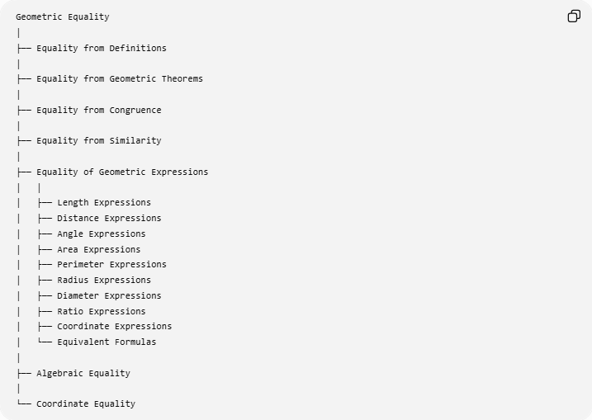
Geometric Equality
│
├── Equality from Definitions
│
├── Equality from Geometric Theorems
│
├── Equality from Congruence
│
├── Equality from Similarity
│
├── Equality of Geometric Expressions
│ │
│ ├── Length Expressions
│ ├── Distance Expressions
│ ├── Angle Expressions
│ ├── Area Expressions
│ ├── Perimeter Expressions
│ ├── Radius Expressions
│ ├── Diameter Expressions
│ ├── Ratio Expressions
│ ├── Coordinate Expressions
│ └── Equivalent Formulas
│
├── Algebraic Equality
│
└── Coordinate Equality
An important distinction is:
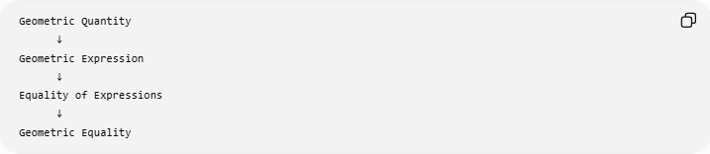
Geometric Quantity
↓
Geometric Expression
↓
Equality of Expressions
↓
Geometric Equality
For example:
$$AB=3x+5$$
and:
$$CD=2x+12.$$
Then:
$$AB=CD$$
produces:
$$\boxed{3x+5=2x+12}.$$

Key Formulas
# Source: AI Source: Provided by: [Data Path: Persons Table -> ID Column: 1, Name_En Column: Motasem Essam] -> From: [ChatGPT] on [7/25/2026]
Segment
$$\boxed{AB+BC=AC}$$
Rectangle area
$$\boxed{A=lw}$$
Rectangle perimeter
$$\boxed{P=2\left(l+w\right)=2l+2w}$$
Triangle area
$$\boxed{A=\frac{1}{2}bh}$$
Circle circumference
$$\boxed{C=2πr=πd}$$
Circle area
$$\boxed{A=πr^{2}=\frac{πd^{2}}{4}}$$
Diameter
$$\boxed{d=2r}$$
Coordinate distance
$$\boxed{AB=\sqrt{{\left(x_{2}-x_{1}\right)}^{2}+{\left(y_{2}-y_{1}\right)}^{2}}}$$
Pythagorean theorem
$$\boxed{a^{2}+b^{2}=c^{2}}$$
Similarity
$$\boxed{\frac{AB}{DE}=\frac{BC}{EF}=\frac{AC}{DF}}$$

Key Points
# Source: AI Source: Provided by: [Data Path: Persons Table -> ID Column: 1, Name_En Column: Motasem Essam] -> From: [ChatGPT] on [7/25/2026]
- Equality of Geometric Expressions means two expressions representing geometric quantities have the same value.
- It is written generally as:
$$\boxed{E_{1}=E_{2}}.$$
- The expressions can represent lengths, angles, distances, areas, perimeters, radii, diameters, ratios, coordinates, or other geometric quantities.
- Different-looking expressions can represent the same quantity:
$$\boxed{2πr=πd}$$
- Geometric expressions can be established from:
  - definitions,
  - geometric theorems,
  - congruence,
  - similarity,
  - algebra,
  - coordinate geometry,
  - metric formulas.
- Equality of complete expressions does not require equality of their individual terms.
- Algebraic properties such as reflexivity, symmetry, transitivity, substitution, addition, and multiplication preserve geometric equality.
- Segment addition, angle addition, area decomposition, and geometric formulas are important sources of expression equality.

Conclusion
# Source: AI Source: Provided by: [Data Path: Persons Table -> ID Column: 1, Name_En Column: Motasem Essam] -> From: [ChatGPT] on [7/25/2026]
$$\boxed{\text{Equality of Geometric Expressions}=\text{Equality between mathematical expressions representing geometric quantities}}$$
The general form is:
$$\boxed{E_{1}=E_{2}}$$
Examples include:
$$\boxed{AB+BC=AC} \\ \boxed{2\left(l+w\right)=2l+2w} \\ \boxed{2πr=πd} \\ \boxed{a^{2}+b^{2}=c^{2}} \\ \boxed{\frac{AB}{BC}=\frac{DE}{EF}}$$
Thus, Equality of Geometric Expressions is the expression-level form of geometric equality, allowing geometric quantities to be represented, compared, transformed, simplified, and proved equal through mathematical expressions.

